Neural networks and deep learning icp-1

Name:sathwik annabathula

700#700759861

Github link: <https://github.com/sathwikannabathula/nn-dl-icp-1>

Video link: <https://vimeo.com/975624677/2e40f0d01c?share=copy>

1. Write a python program for the following:

Input the string “Python” as a list of characters from console, delete at least 2 characters, reverse the resultant string and print it.

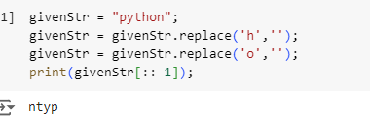

Take two numbers from user and perform at least 4 arithmetic operations on them.

2. Write a program that accepts a sentence and replace each occurrence of ‘python’ with ‘pythons’.

3.Use the if statement conditions to write a program to print the letter grade based on an input class score. Use the grading scheme we are using in this class



